FOR IMMEDIATE RELEASE

LG SHOWCASES SMART HEALTHCARE SOLUTIONS AT HIMSS 2025

LG All-in-One Thin Client, Medical, and Diagnostic Monitors Take Centerstage at IGEL, rfIDEAS, Ergotron, XenTegra, Lenovo, Accessium Group, and Konica Minolta Partner Exhibits

LAS VEGAS, March 3, 2025 — LG Electronics USA’s business solutions group is making a strong presence at HIMSS 2025, showcasing innovative healthcare solutions at seven partner exhibits from March 3-6 at the Venetian Convention and Visitors Center in Las Vegas. With proven products for reliable deployment, LG continues to be a trusted partner for CTOs, IT Managers, and decision-makers looking for dependable solutions to support their healthcare projects.
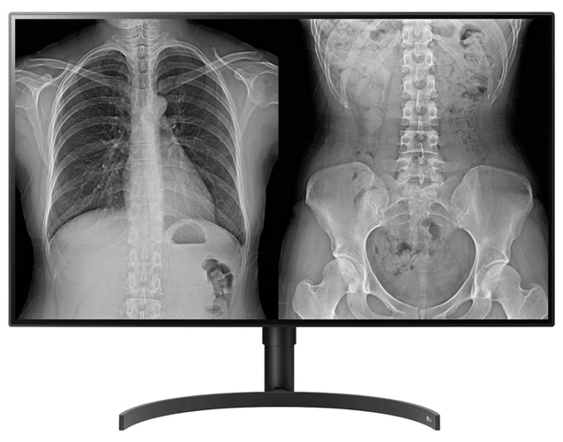
“We’re putting the spotlight on how our smarter healthcare displays work optimally with our partner solutions at HIMSS 2025,” explained Stephen K. Hu, LG Electronics USA’s head of medical displays. “Together with IGEL, rfIDEAS, Ergotron, XenTegra, Lenovo, Accessium Group, and Konica Minolta, we want attendees to see firsthand how we are transforming healthcare IT with secure, high-performance solutions that make everyday workflows simpler. LG is fully focused on offering comprehensive solutions, including thin clients, medical monitors, digital signage, and more, designed to support diverse healthcare needs across various environments within healthcare facilities. We’re excited to join with our partners to meet with industry professionals to explore how our solutions can play a strategic role in enhancing the quality of healthcare they deliver to their patients.”

According to Hu, LG is emphasizing its commitment to strong partner collaboration to deliver secure endpoint solutions that make cloud-based healthcare operations smoother. The company is also spotlighting the versatility of its thin-client devices built to enhance productivity, simplify IT management, and improve security in healthcare settings. LG is solving real-world healthcare challenges, whether it’s keeping sensitive data safe or making technology more user-friendly for clinicians.

At the IGEL (#748), rfIDEAS (#643), Ergotron (#5732), and XenTegra (#5227) booths, LG is featuring its 24CR67iK6P All-in-One Thin Client with Intel® Pentium processor, dual-band RFID, Webcam and Mic. The All-in-One Thin Client makes cloud computing easy and secure, offering medical facilities an endpoint that delivers end-user performance and strong data protection within a secure, reliable virtual desktop experience that is easy to implement and manage.

The monitor’s RFID module allows multiple people to use the device as a personalized thin client that is useful for shift work, allowing various staff members to log into the personal virtual desktop on a single device. The RFID module also allows the end-user the ability to control who is authorized to log into the thin client. Its full HD IPS display delivers a wide viewing angle for sharing charts and medical information with others. Its advanced Quad-core Processor and a powerful system memory option help get work done quickly and easily.

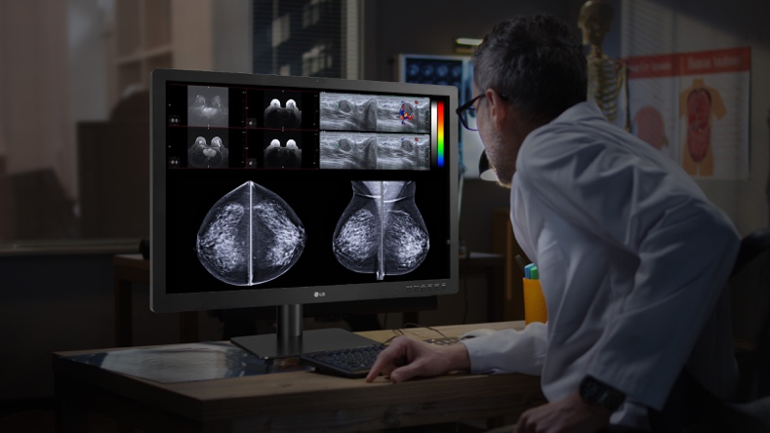
What’s more, LG is also teaming up with rfIDEAS to bring attention to the key access points across the healthcare ecosystem.

At the Lenovo (#2025), Accessium Group (#2474), and Konica Minolta (#443) booths LG is showcasing its 32HQ713D-B medical, 24HR513C diagnostic, and 32HL512D diagnostic monitors.

The 32-inch 32HQ713D-B medical monitor provides reliable image quality for critical assessment. Its black panel delivers deep black levels leading to the extremely sharp expression medical professionals need. With a significantly high contrast ratio of 2000:1, 32HQ713D-B helps to come up with clear image definition with detailed low gray expression. Its multi-resolution mode (8/6/4MP) allows professionals to adjust the resolution of the monitor to better fit individual needs. In the pathology mode, the monitor provides image clarity and accuracy equal to a microscope.

The 27-inch 27HJ713C-B 8MP IPS diagnostic monitor provides the ideal brightness for secondary review. The 178-degree wide viewing angle lets patients and doctors see accurately reproduced images with minimal distortion. With 350nits (Typ.) brightness and sRGB 99% of the color space, the monitor offers bright, vivid color expression and high resolution for image clarity. The monitor’s DICOM Part 14 Gamma adjusts the greyscale levels of medical images from various medical imaging modalities. Also, it ensures a 250 nit brightness compliant to the ACR-AAPM-SIIM secondary review brightness guideline.

What’s more, a sensor measures the backlight brightness stability and automatically compensates for brightness fluctuations caused by display aging for a consistently stable display throughout the usage lifespan. Built-in Flicker Safe technology virtually eliminates flickering to help promote eye comfort. while its ergonomic stand with two-way pivot adjustment realizes an optimized diagnostic workspace. Rotate two monitors in portrait and use side-by-side for the ultimate reading experience.

The 31.5-inch 32HL512D 8MP Nano IPS diagnostic display is designed to help facilitate diagnosis of medical images. The monitor features multi-resolution and clinical pathology modes, auto luminance calibration, PBP/dual controller, and an ergonomic stand. The 178-degree wide viewing angle enables clinicians to more accurately read multiple screens without loss in contrast ratio. Its built-in backlight sensor dynamically measures and maintains calibrated DICOM brightness that enhances diagnostic reading consistency and confidence over time.

To learn more about LG’s presence at HIMSS 2025, click here. For images, click here.

# # #
About LG Electronics USA
LG Electronics USA serves commercial display customers in the U.S. lodging and hospitality, digital signage, systems integration, healthcare, education, government and industrial markets. Based in Lincolnshire, Ill., with its dedicated engineering and customer support team, LG’s U.S. Media Entertainment Solution B2B division delivers business-to-business technology solutions tailored to the particular needs of business environments. Eleven-time ENERGY STAR® Partner of the Year LG Electronics USA Inc., headquartered in Englewood Cliffs, N.J., is the North American subsidiary of LG Electronics Inc., a leading smart life solutions company with annual global revenues of more than $60-billion from consumer electronics, home appliances, HVAC solutions and vehicle components. For more information, please visit www.LGSolutions.com.

Media Contacts:

LG Electronics USA

Kim Regillio
+1 815 355 0509
kim.regillio@lge.com
www.LGsolutions.com
Caleigh McDaniel
caleigh@griffin360.com

